**Object Oriented Programming (OOP) – IT2030**

**Week 03**

**Objective**

Students should understand Object Memory Allocation Method overloading, Overriding and passing objects as parameter.

Group the student’s row wise and ask them to do as a group activity. After the allocated time, volunteer student from each group can write the answer on the white board and discuss why they have given that answer.

**Exercise -01 (Objects)**

Mobile class looks like below.

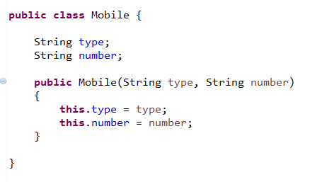

Draw how Heap memory will looks like, in each and every line in the bellow code.

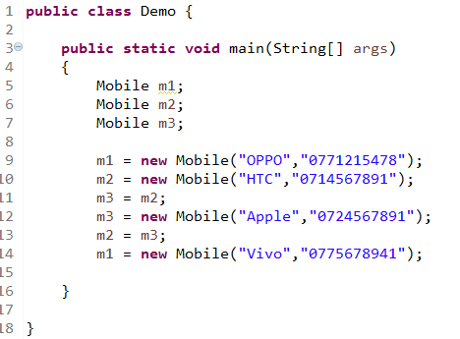

**Exercise -02 (Objects)**

Now you have another class called Television 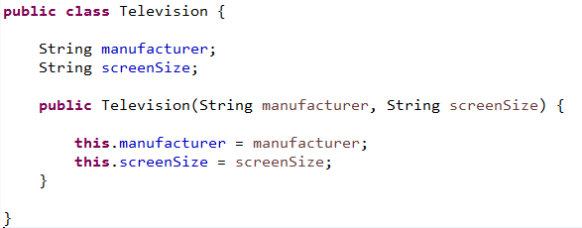

Draw how Heap memory will looks like, in each and every line in the bellow code.

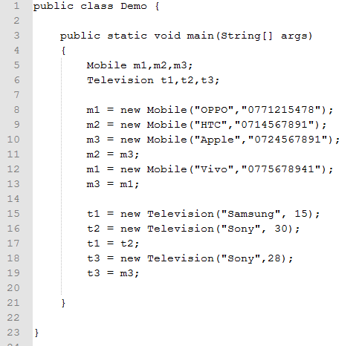

**Exercise 03 (Passing objects as parameter)**

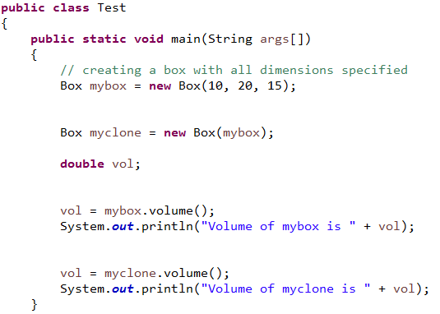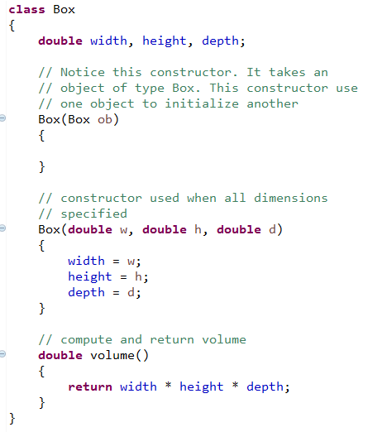

Write down the implementation for the constructor which takes an object as a parameter and show what will be the output of this program.

**Exercise - 04 (Overloading)**

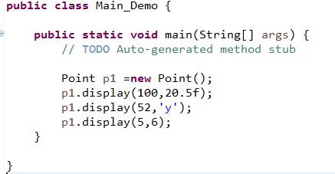What will be the standard output when the following program is compiled and run?

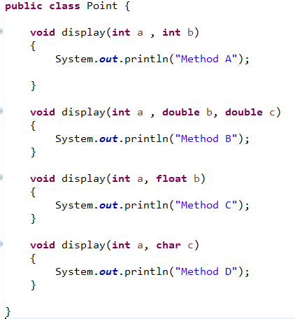

**Exercise 05 (Overloading)**

You need to write methods, to add two integer numbers, three integer numbers or four integer numbers, in one class. And then try call them in different class which has a main method. Call all the three methods by passing suitable arguments.

**Exercise - 06 (overriding)**

We have three classes: Parent class *Shape* and child classes *Circle, Rectangle* which extend *Shape* class

All these class has common method *calculateArea().*

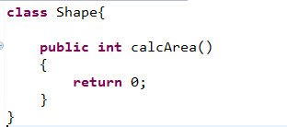

Write down the implementation for the *Rectangle* and *Circle* classes. There use suitable attributes and override the calcArea() methods.

Create a main class, which contains the main method and call those methods.